Evaluación preliminar de SensiTest ™ Colistin, un método basado en microdilución en caldo para evaluar las CIM de colistina

Edoardo Carretto, Flavia Brovarone, Mariagrazia Sciascia, Giuseppe Russello
S.O.C. Microbiologia – IRCCS Arcispedale Santa Maria Nuova, Reggio Emilia, Italy

INTRODUCTION
Colistin is often the last option to treat severe infections caused by multidrug- resistant microorganisms, such as Pseudomonas aeruginosa, Acinetobacter baumannii and carbapenem-resistant enterobacteriaceae.
Until very recently, colistin resistance was always thought to be chromosomally encoded, allowing vertical transmission only, being resistance rare and self-limiting. This kind of resistance is determined by a wide variety of mechanisms, depending on the microorganisms involved. Recently a plasmid-mediated resistance (mcr-1) was described: this resistance trait encodes for a phosphoethanolamine transferase and it was found in many countries, becoming rapidly matter of concern worldwide.
Almost contemporarily, international committees pointed out that antimicrobial susceptibility testing (AST) for colistin should be performed only by using broth microdilution (BMD) techniques, because other methods, including agar dilution, disk diffusion and gradient diffusion, have been demonstrated to be unreliable. Therefore, the development of commercial test for colistin AST based on BMD is highly desirable.
Here we present the evaluation of the pre-commercial version of a BMD test, the SensiTest™ Colistin (STC, Liofilchem, Italy), a compact 4-test panel containing the dried up antibiotic in 7 two-fold dilutions (0.25 - 16 µg/ml) and one well as growth control. The system will be proposed to evaluate colistin AST using a BMD method that complies the recommendations of international standards (i.e. CLSI, EUCAST, ISO) in a simpler and less time-consuming way.
STC was compared with the classical BMD technique, performed according to the recommendations of CLSI and EUCAST and used as gold standard, and also with the results of an automated system, the Phoenix 100™ (PHX, Becton Dickinson, USA).
RESULTS

The study synopsis is shown in table 1. Examples of the STC panels are shown in figures 1-3.
Agreement between STC and BMD-CLSI – A good agreement was obtained for 209 out of the 215 strains tested (97,21%). For 100 strains the same MIC value was obtained for the two methods, whereas a difference ± 1 log was documented for 109 isolates.
Disagreement was found for 2 E. coli and 2 Enterobacter aerogenes isolates, as well for one strain of Hafnia alvei and one isolate of Salmonella species. The discrepancy did not change the strains’ categorization in four cases. A major error (resistant instead of susceptible) was recognized for one strain of E. aerogenes, whereas a very major error (susceptible instead of resistant) was documented for the strain of Salmonella species.
Reproducibility of STC - One out the 6 isolates that were replicated 10-times gave always the same MIC, whereas for 3 strains one replicate differed for 1 log to the expected. One E. coli strain had 3 values differing for 1 log, and for the last strain (a colistin resistant K. pneumoniae) there was 4 replicates which differed from 1 log from the expected value. We did not have results with ±2 log of difference and the overall punctual reproducibility among replicates (i.e., same MIC), was 50/60 (83,3%).
Agreement between PHX and BMD-CLSI – Also PHX showed a 96,74% agreement with the BMD-CLSI: in this case, the 7 discordant strains resulted in one major error for a Pseudomonas aeruginosa strain, 5 very major error (E. coli, Hafnia alvei and two Salmonella species) and in one case did not change the strains’ categorization.
CONCLUSIONS

- The spread of colistin-resistant microorganisms has become matter of concern worldwide, after the discovery of a plasmid-mediated mechanism of resistance that more often determine a low level resistance (MICs of 4-8 µg/ml).
- The recent warnings of EUCAST about the unreliability of agar dilution, disk diffusion and gradient diffusion to evaluate the colistin susceptibility, makes mandatory the development of new diagnostic tool for the clinical microbiology laboratories.
- In our experience the STC is a simple but highly reliable test to assess the colistin susceptibility. The preparation procedure is easy and fast and the results evaluation is quite simple. For some strains, such as Hafnia alvei, which presents a kind of intrinsic and constitutive resistance to colistin (Nordmann et al., 2016), it is important to carefully evaluate any growth in the wells, even if as pinpoint microcolonies (figure 3).
- Therefore, the STC may be proposed both as a first-line test and as a confirmatory test (e.g. after having the results of automated instruments), for particular conditions.
- Further studies are needed to evaluate the possibility to use the same panel in different days for different patients, after sealing the rows previously inoculated.
- Being an open system, it could be possible, after the reading, to evaluate also the minimal bactericidal concentration spotting 1 to 10 µl onto a Mueller Hinton agar plate (figure 4).

Figure 3 – STC test, first two rows. The arrows indicated pinpoint colonies of Hafnia alvei.
SELECTED REFERENCES
Caniaux I, van Belkum A, Zambardi G. et al. – 2016 – MCR: modern colistin resistance - Eur J Clin Microbiol Infect Dis. 2017 36(3):415-420.
CLSI – 2016 – Methods for dilution Antimicrobial Susceptibility Tests for Bacteria That Grow Aerobically; Approved Standard - Eleventh Edition. CLSI document M07-A10. Wayne, PA: Clinical and Laboratory Standards Institute EUCAST – 2016 – Recommendations for MIC determination of colistin - March 2016. www.eucast.org/ast_of_bacteria/warnings/#c13111.
ISO 20776-1:2006. Clinical laboratory testing and in vitro diagnostic test systems -- Susceptibility testing of infectious agents and evaluation of performance of antimicrobial susceptibility test devices - Part 1: Reference method for testing the in vitro activity of antimicrobial agents against rapidly growing aerobic bacteria involved in infectious diseases.
Liu YY, Wang Y, Walsh TR, et al. – 2016 – Emergence of plasmid-mediated colistin resistance mechanism MCR-1 in animals and human beings in China: a microbiological and molecular biological study – Lancet Infect Dis 16:161-168. Nordmann P, Assouvie L, Prod'Hom G et al. - 2016 – Screening of plasmid-mediated MCR-1 colistin-resistance from bacteremia. Eur J Clin Microbiol Infect Dis 35:1891-1892.
MATERIALS AND METHODS
Strains collection – 215 bacterial strains were evaluated. All the isolates were collected from clinical samples and previously stored in laboratory collections. They were selected on the basis of the following characteristics: 45 enterobacteriaceae with reduced susceptibility to colistin (7 of them were Escherichia coli carrying the mcr-1 gene, as demonstrated using an in house PCR); 12 carbapenem resistant Klebsiella pneumoniae; 155 strains isolated from blood cultures. Three reference strains (E. coli ATCC® 25922, Pseudomonas aeruginosa ATCC® 27853, E. coli NCTC® 13846) were included as controls. The list of the isolates tested is shown in table 1.
PHX - The tests were performed according to the manufacturer’s recommendations.
STC – Briefly, a saline 0.5 McFarland suspension of the microorganism to be tested was diluted 1:20 in saline (solution A). 0,4 ml of this solution was then added to the 3,6 ml tube of Mueller-Hinton broth II provided in the kit (solution B). 100 μl of the solution B were then dispensed into each well in a row. The panels were then incubated at 36 ± 2°C for 16-20 hours in ambient air. The results were then evaluated visually from two different operators. Any turbidity or button at the bottom of the well was considered positive.
The two ATCC reference strains, 3 E.coli (one of them, mcr-1 positive) and 1 carbapenem resistant K. pneumoniae were tested as replicates 10-times, to evaluate the test reproducibility.
BMD-CLSI - Was performed in accordance with the ISO standard broth microdilution (BMD) method (20776-1), which has been demonstrated to work well for Enterobacteriaceae, P. aeruginosa, and Acinetobacter species.
Eleven working concentration of colistin (ranging from 64 µg/ml to 0.064 µg/ ml) were prepared in separate tubes containing cation-adjusted Mueller- Hinton broth (CAMHB). 50 µl of each intermediate concentration were dispensed into the wells of the microwell plates.
For each strain tested a positive growth control was included in the first well of the plate.
Isolated bacterial colonies were selected from a 18-24h blood agar culture and transferred to a CAMHB tube. The broth was incubated overnight at 35–37°C and the turbidity adjusted to 0.5 McFarland standard and the suspension was then diluted in broth to obtain a final bacterial concentration of 5 × 105 colony forming units/ml.
Finally, 50 µl of bacterial suspension were added to each well of the 96-well microplates, which were incubated in an ambient air incubator at 35°C ± 2°C for 16-20 hours. The MICs were determined as the lowest concentration that completely inhibits bacterial growth in the wells.
Agreement between methods – Two methods were considered in agreement when they had same MIC value or with a difference of ±1 log.
Figure 4 – Evaluation of the bactericidal effect by sampling of 1 μl of the resuspended wells of a strain having an MIC of 8 μg/ml (MIC = MBC).

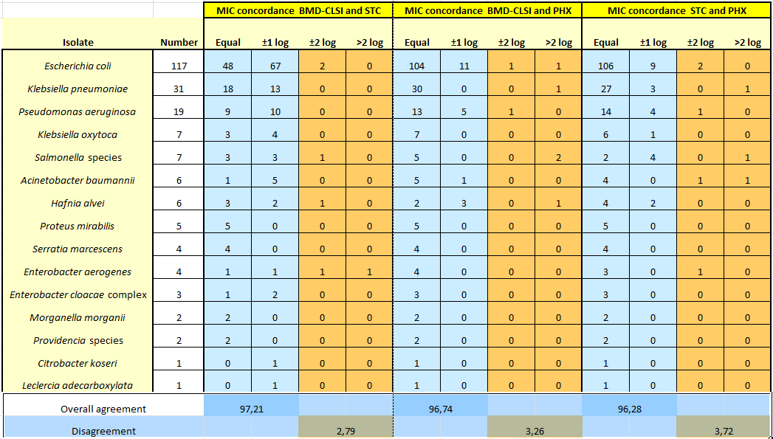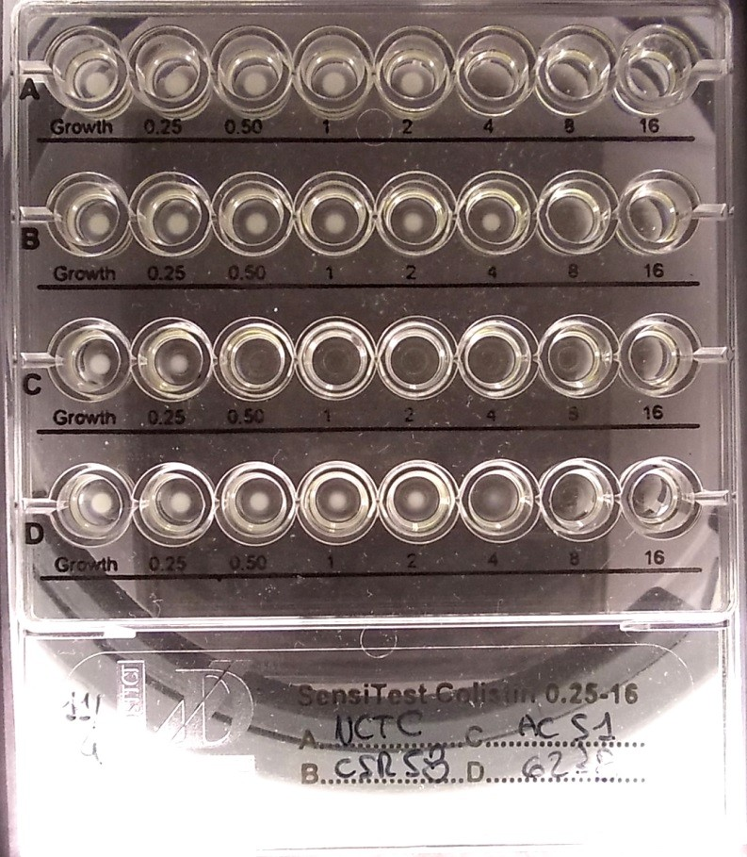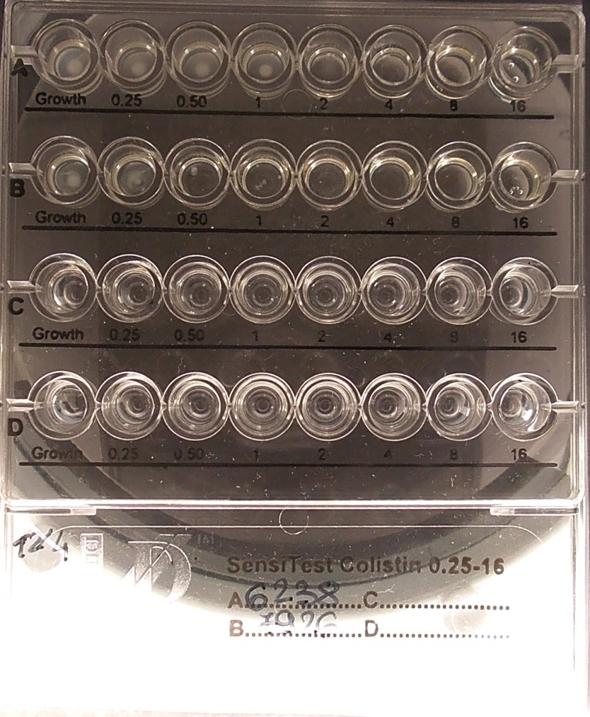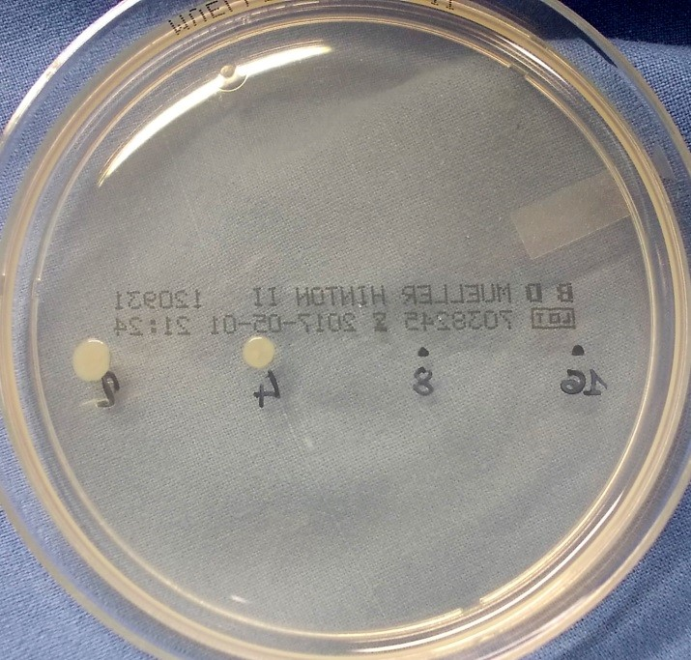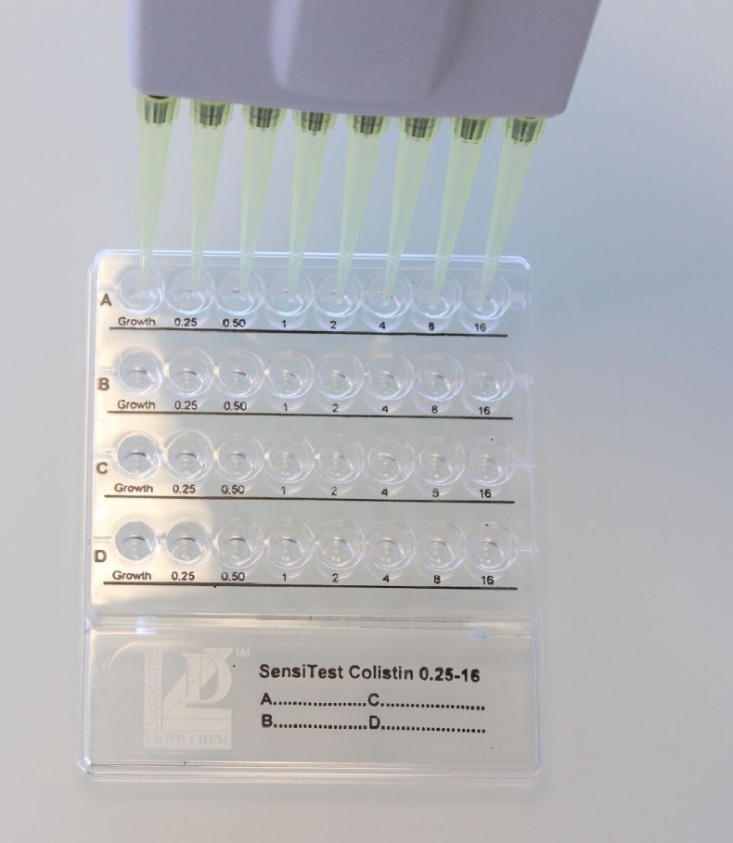Figure 1 – Inoculation of a SensiTest™ Colistin panel.
Figure 2 – Results of a STC test. The well on the right of the red line is the value of the MIC for the isolate.

Table 1 – Study synopsis

Copyright © 2017, Edoardo Carretto. For contact: edoardo.carretto@asmn.re.it

